Need to make following changes
Dataset and preprocessing:
- Over 60% of the input tokens are boilerplate: CREATE, TABLE, VARCHAR(255), DECIMAL(10,2), INT, PRIMARY KEY, parentheses, and semicolons. Example: Question: What is the total volume of timber sold...? | Schema: CREATE TABLE salesperson (salesperson_id INT, name TEXT, region TEXT); CREATE TABLE timber_sales (sales_id INT, salesperson_id INT, volume REAL, sale_date DATE);
  - SQL Keyword Casing Inconsistency: Some queries write: SELECT SUM(volume) as total_volume (SELECT/SUM uppercase, as lowercase).
  - Others write: select count(*) from ... (all lowercase)
  - Why it's hurting accuracy:During training with CrossEntropy loss, if the model predicts AS and the target happens to be lowercase as, the model receives a severe loss penalty despite the logic being 100% correct!
- Bottleneck 4: Task Mixing (Analytics vs. DDL/Deletes)
  - Our dataset inspection shows the following distribution:
    - Analytics & Queries (SELECT): ~90%
    - Data Manipulation (DELETE, UPDATE, INSERT): ~8%
    - Data Definition (CREATE TABLE, ALTER TABLE): ~2%
- Hyper parameter tuning (Feed-forward dimension (d_ff: 512 $→$1024): Setting $d_{ff}=4×d_{model}$($1024$) will give each layer double the reasoning capacity without slowing down attention.)
- Pointer generator(copy mechanism)
- Implement weight typing
- Increase the number of epochs
- Is the present tokenisation fine ; what is the fallback
- {
- "d_model": 256,
- "num_heads": 4,
- "layers": 10,
- "d_ff": 512,
- "dropout": 0.4,
- "src_vocab_size": 12000,
- "tgt_vocab_size": 12000
- }

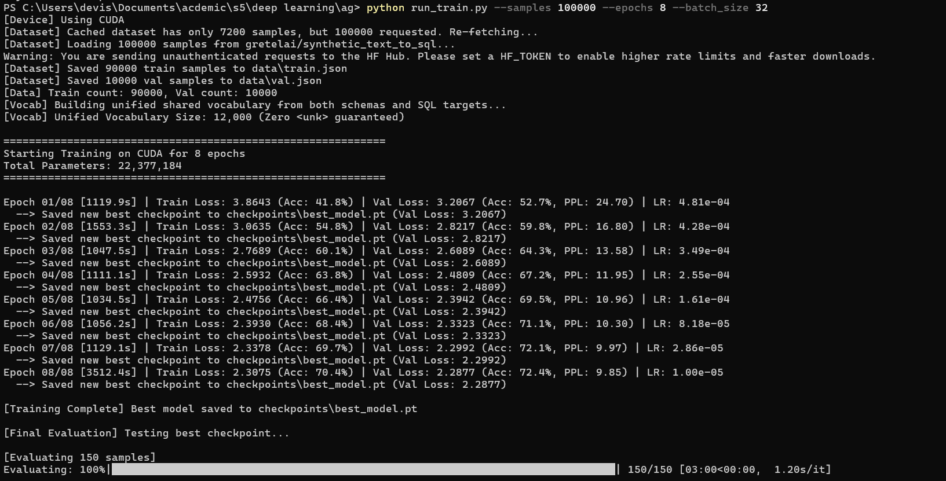

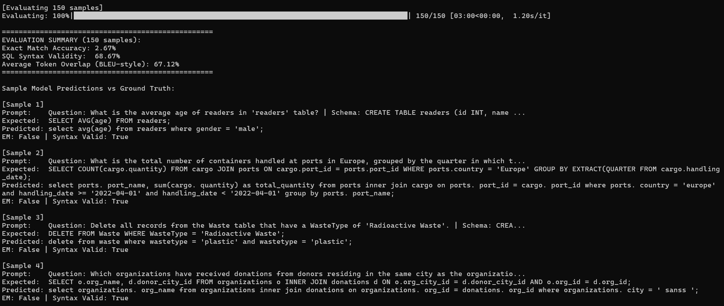

Sdfg
